Note: This document is “view only”. Please create a copy of this document and save it to your drive.

**SOP- Subscriber Maintenance-Systems Vault**

**PREREQUISITE**

[Master: SOP- Operations Management -Systems Vault](https://docs.google.com/document/u/0/d/1gIeHLaKTWivg43RAx2fHPd14QktmUju8dcElYWywAXM/edit)

[Teamwork PM](http://sarahnoked.com/teamwork)

[Ontraport](http://sarahnoked.com/ontraport)

SN Ontraport Optouts and Hardbounces

SN Ontraport Inactive Contacts

**PURPOSE**

To ensure that our subscriber list stays up to date and active.

**POLICY**

There are both weekly and monthly recurring task lists in [Teamwork PM](http://sarahnoked.com/teamwork) for Ontraport Contact Maintenance.

**Here’s what happens weekly:**

1. We update and/or remove contacts flagged as “OP Engineering says: Contact Unverified” (note: these unverified contacts often go on to purchase, which is why we screen them) hard bounced, no first name and no email address.

These contact lists are identified in Ontraport as:

* CU: Hard Bounced
* CU: No Email Address
* CU: No First Name
* CU: Unverified Contacts

These flagged contacts will come up on these contact lists: CU: Unverified Contacts

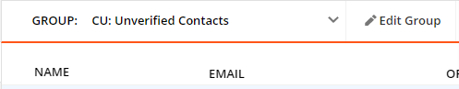

**Here’s what happens monthly:**

1. We update, export and delete contacts flagged as inactive or unsubscribed, as long as they do not have Purchase, Payment Delinquent, Payment on Hold or BANNED tags.

These contact lists are identified in Ontraport as: CU: Inactive + ready to delete (for at least 180 days)

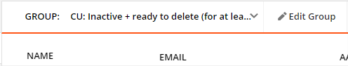

Note: We do not remove contacts who are tagged with: Purchase Behavior Tags, SN Current Clients, SN Past Clients, Agency Clients, Lead Mgt: Agency - Agency Leads, BANNED, Payment Delinquent and Payment on Hold (these contacts will not show up in the contact group).

**PARTY**

Tech VA

**PROPERTY**

Online Business Manager

**PROCESS**

Part 1: Remove Hard Bounced Contacts

Part 2: Delete Contacts with No Email Address

Part 3: Add First Name for Contacts Without First Name Fields (If possible)

Part 4: Remove Tag “OP Engineering says: Contact Unverified” from Contacts

Part 5: Export, Save and Delete Inactive Contacts (Recurs Monthly)

**PROCEDURE**

**Part 1: Remove Hard Bounced Contacts**

1. Navigate to ‘CU: Hard Bounced’ contact group in [Ontraport](http://ontraport.com)
2. Select all contact in the contact group and export

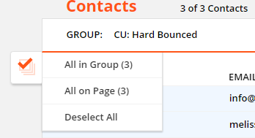 and 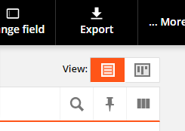

1. Export All the data of the contacts

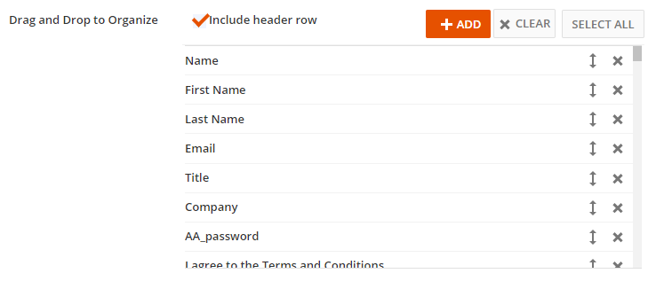

1. Once the CSV is obtained, rename the file following this format:

SN OP Hard Bounces May 30 2018.csv

1. Upload the file to SN Ontraport Optouts and Hardbounces
2. Go back to the contact group, select all contacts and delete. OP may prompt a confirmation box that requires you to type in “DELETE” in full caps to confirm the deletion. Just proceed and type in “DELETE”

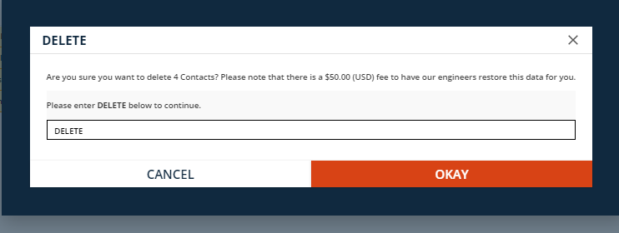

**Part 2: Delete Contacts with No Email Address**

1. Navigate to ‘CU: No Email Address’ contact group in [Ontraport](http://ontraport.com)
2. Select all contacts in the group and delete. Follow Part 1, #6 of this SOP.

**Part 3: Add First Name for Contacts Without First Name Fields (If possible)**

1. Navigate to ‘CU: No First Name’ contact group in [Ontraport](http://ontraport.com)
2. If the first name is evident from the email address/contact details, update the field “First Name”
3. If the first name is not available, leave blank.

**Part 4: Remove Tag “OP Engineering says: Contact Unverified” from Contacts**

1. Navigate to ‘CU: Unverified Contacts’ contact group in [Ontraport](http://ontraport.com)
2. Select “all contacts” then navigate to “tags” and remove “OP Engineering says: Contact Unverified”

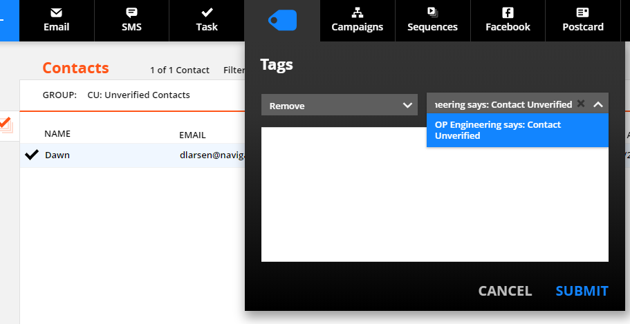

**Part 5: Export, Save and Delete Inactive Contacts (Recurs Monthly)**

1. Navigate to ‘CU: Inactive + ready to delete (for at least 180 days)’ contact group in [Ontraport](http://ontraport.com)
2. Select all contacts in the contact group and export. Follow Part 1, #2-6 of this SOP with this file name format - SN OP Inactive Contacts July 31 2020.csv
3. Save the file in SN Ontraport Inactive Contacts.

**Created by:**

**Department:** Operations & Support

**Date:**

**Revised:**

**Revised by:**